MLOps Hands-on Session 1
ML Model Deployment Strategies — Kidney Disease Dataset
Theory + Step-by-Step Hands-on + Troubleshooting + Viva Questions
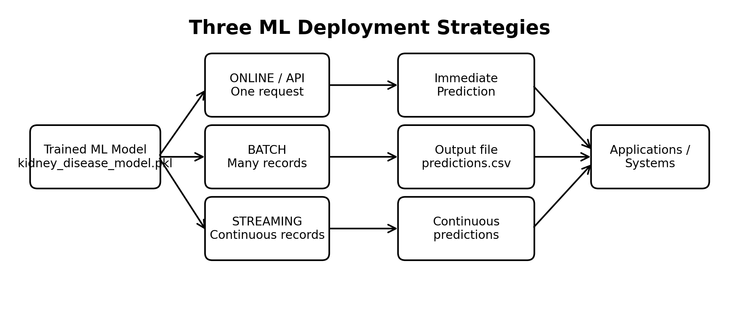
Figure 1. Three deployment strategies using the same trained ML model.

Session Overview
This laboratory introduces three common ways of deploying machine-learning inference: Online/API inference, Batch inference, and Streaming inference. The same kidney-disease classification model is reused for all three demonstrations so that students can clearly separate the deployment strategy from the model itself.

1. Learning Objectives
- Explain what ML model deployment means and why deployment is part of the MLOps lifecycle.
- Differentiate Online/API, Batch, and Streaming inference.
- Run an online prediction for a single record.
- Run batch predictions for many records and save the results.
- Simulate streaming inference using incoming dataset records.
- Identify suitable use cases and trade-offs for each strategy.
- Understand the transition from deployment strategy to model serving and containerization.

2. Prerequisites
- Python 3.x / Anaconda environment.
- pandas, scikit-learn and joblib installed.
- The trained artifact kidney_disease_model.pkl.
- The kidney_disease.csv dataset.
- Basic Python and pandas knowledge.

3. Dataset and Model Context
For this laboratory, kidney_disease.csv is used as the example dataset. The dataset has 400 records and 26 columns. The target is classification, while id is treated as an identifier and is not used as a predictive feature. The trained artifact should contain the complete preprocessing pipeline together with the classifier so that the same transformations are applied during inference.
Core principle: Train once → Save the complete pipeline → Reuse it for different deployment strategies.

4. Theory: What is ML Model Deployment?
ML model deployment is the process of making a trained model available so that it can receive new input data and produce predictions in a usable environment. Training happens on historical data; deployment happens after training and focuses on inference.
Typical lifecycle:
Data → Training → Evaluation → Model Artifact → Deployment → Inference → Monitoring
Deployment is not the same as model serving. A deployment strategy describes how inference is triggered and processed (online, batch, or streaming). Model serving describes the software interface or service that exposes the model, such as a REST API. Docker later packages that serving application and its dependencies.

5. Online / API Inference
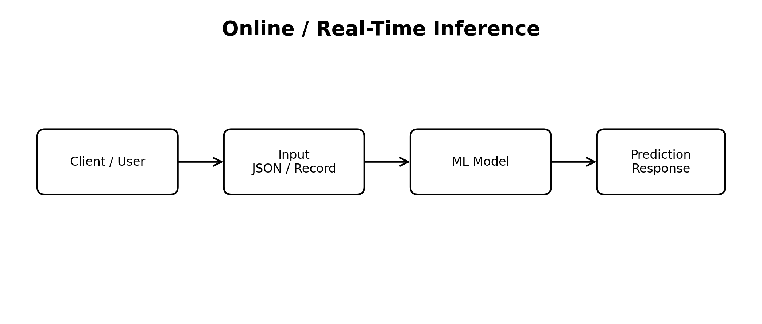
Figure 2. Online inference processes a request and returns a prediction immediately.
Online inference is used when an application needs a prediction for an individual request or a very small request at a time. The request arrives, preprocessing is applied, the model predicts, and a response is returned.
Typical examples:
- Web or mobile prediction applications
- Fraud or risk scoring APIs
- Recommendation requests
- Interactive decision-support systems

6. Batch Inference
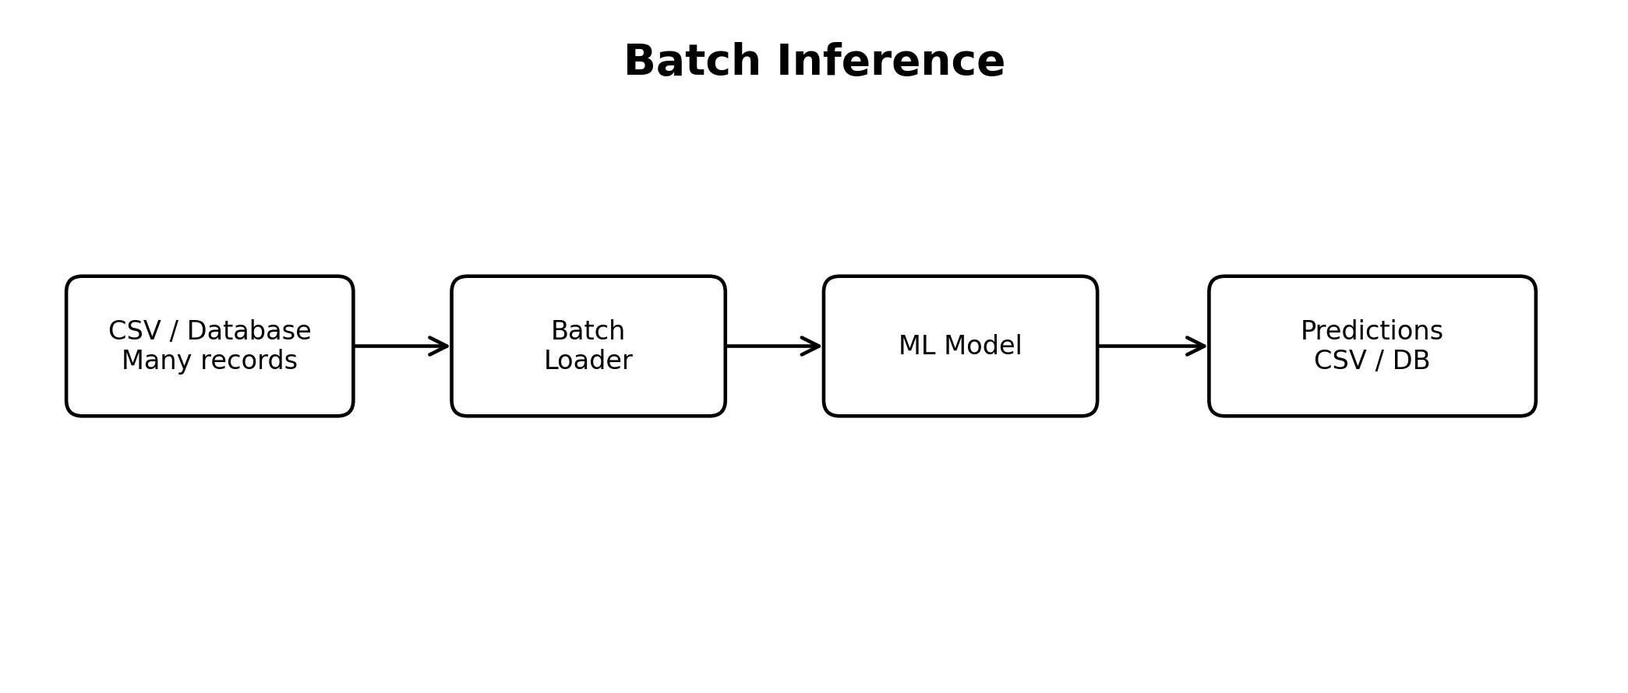
Figure 3. Batch inference processes a collection of records together.
Batch inference processes a group of records at scheduled or on-demand intervals. It is useful when immediate response is not required and large amounts of data can be processed efficiently.
Typical examples:
- Daily or weekly prediction jobs
- Scoring a database table
- Generating reports
- Offline analytics

7. Streaming Inference
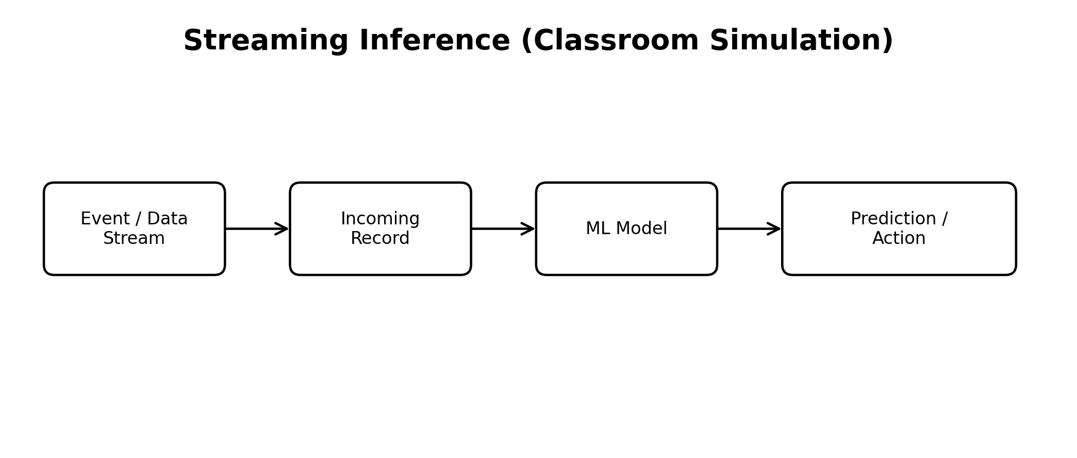
Figure 4. Streaming inference processes records/events continuously; this lab simulates the stream with Python.
Streaming inference processes data as events arrive. In production this may involve a message broker or event platform, but this introductory laboratory uses successive rows from the dataset and a short delay to simulate continuously arriving records.
Typical examples:
- IoT sensor events
- Vehicle telemetry
- Transaction monitoring
- Continuous application activity

8. Online vs Batch vs Streaming
Aspect | Online/API | Batch | Streaming
Input pattern | Individual request | Group of records | Continuous events
Response | Immediate | After batch completes | Continuous / near real-time
Typical source | API client | CSV / DB / object storage | Event or message stream
Example | Web prediction | Daily scoring | IoT monitoring
Classroom implementation | Python script / later FastAPI | CSV → predictions.csv | Loop + delay

9. Hands-on Setup
Recommended directory structure:
MLOps_Deployment/
└── Session_1_Deployment_Strategies/
├── kidney_disease.csv
├── kidney_disease_model.pkl
├── online/
│ └── online_prediction.py
├── batch/
│ └── batch_prediction.py
└── streaming/
└── streaming_prediction.py
If the model artifact was already created in the earlier model-training practical, reuse it. Do not retrain the model for each deployment strategy.

10. Hands-on A — Online Inference
Create train_model.py
import os
import joblib
import pandas as pd

from sklearn.model_selection import train_test_split
from sklearn.pipeline import Pipeline
from sklearn.compose import ColumnTransformer
from sklearn.impute import SimpleImputer
from sklearn.preprocessing import (
StandardScaler,
OneHotEncoder
)
from sklearn.ensemble import RandomForestClassifier

from sklearn.metrics import (
accuracy_score,
precision_score,
recall_score,
f1_score,
classification_report
)

# =====================================================
# 1. LOAD DATASET
# =====================================================

DATA_FILE = "kidney_disease.csv"

df = pd.read_csv(DATA_FILE)

print("Dataset loaded successfully.")
print("Dataset shape:", df.shape)

# =====================================================
# 2. BASIC INFORMATION
# =====================================================

print("\nColumns:")
print(df.columns.tolist())

print("\nMissing values:")
print(df.isnull().sum())

# =====================================================
# 3. CLEAN TARGET
# =====================================================

df["classification"] = (
df["classification"]
.astype(str)
.str.strip()
)

print("\nTarget distribution:")
print(df["classification"].value_counts())

# =====================================================
# 4. SEPARATE FEATURES AND TARGET
# =====================================================

X = df.drop(
"classification",
axis=1
)

y = df["classification"]

# Remove identifier
if "id" in X.columns:
X = X.drop(
"id",
axis=1
)

print("\nFeature shape:", X.shape)
print("Target shape :", y.shape)

# =====================================================
# 5. IDENTIFY COLUMN TYPES
# =====================================================

numeric_features = X.select_dtypes(
include=["int64", "float64"]
).columns.tolist()

categorical_features = X.select_dtypes(
include=["object", "category", "bool"]
).columns.tolist()

print("\nNumerical features:")
print(numeric_features)

print("\nCategorical features:")
print(categorical_features)

# =====================================================
# 6. TRAIN-TEST SPLIT
# =====================================================

X_train, X_test, y_train, y_test = train_test_split(
X,
y,
test_size=0.20,
random_state=42,
stratify=y
)

print("\nTraining shape:", X_train.shape)
print("Testing shape :", X_test.shape)

# =====================================================
# 7. NUMERICAL PREPROCESSING
# =====================================================

numeric_pipeline = Pipeline(
steps=[
(
"imputer",
SimpleImputer(
strategy="median"
)
),
(
"scaler",
StandardScaler()
)
]
)

# =====================================================
# 8. CATEGORICAL PREPROCESSING
# =====================================================

categorical_pipeline = Pipeline(
steps=[
(
"imputer",
SimpleImputer(
strategy="most_frequent"
)
),
(
"encoder",
OneHotEncoder(
handle_unknown="ignore"
)
)
]
)

# =====================================================
# 9. COMBINE PREPROCESSING
# =====================================================

preprocessor = ColumnTransformer(
transformers=[
(
"num",
numeric_pipeline,
numeric_features
),
(
"cat",
categorical_pipeline,
categorical_features
)
]
)

# =====================================================
# 10. CREATE MODEL
# =====================================================

model = RandomForestClassifier(
n_estimators=100,
random_state=42
)

# =====================================================
# 11. COMPLETE PIPELINE
# =====================================================

ml_pipeline = Pipeline(
steps=[
(
"preprocessor",
preprocessor
),
(
"model",
model
)
]
)

# =====================================================
# 12. TRAIN
# =====================================================

print("\nTraining model...")

ml_pipeline.fit(
X_train,
y_train
)

print("Training completed.")

# =====================================================
# 13. EVALUATE
# =====================================================

y_pred = ml_pipeline.predict(
X_test
)

accuracy = accuracy_score(
y_test,
y_pred
)

precision = precision_score(
y_test,
y_pred,
average="weighted",
zero_division=0
)

recall = recall_score(
y_test,
y_pred,
average="weighted",
zero_division=0
)

f1 = f1_score(
y_test,
y_pred,
average="weighted",
zero_division=0
)

print("\n==============================")
print("MODEL EVALUATION")
print("==============================")

print(
f"Accuracy : {accuracy:.4f}"
)

print(
f"Precision: {precision:.4f}"
)

print(
f"Recall : {recall:.4f}"
)

print(
f"F1-score : {f1:.4f}"
)

print("\nClassification Report:")
print(
classification_report(
y_test,
y_pred,
zero_division=0
)
)

# =====================================================
# 14. SAVE COMPLETE PIPELINE
# =====================================================

MODEL_FILE = (
"kidney_disease_model.pkl"
)

joblib.dump(
ml_pipeline,
MODEL_FILE
)

print(
f"\nModel pipeline saved as: "
f"{MODEL_FILE}"
)

# =====================================================
# 15. VERIFY FILE
# =====================================================

print(
"\nFile exists:",
os.path.exists(MODEL_FILE)
)

if os.path.exists(MODEL_FILE):

file_size = (
os.path.getsize(MODEL_FILE)
/ 1024
)

print(
f"File size: "
f"{file_size:.2f} KB"
)
kidney_disease_model.pkl is created

Create: Session_1_Deployment_Strategies/online/online_prediction.py
import joblib
import pandas as pd
# Load trained model
model = joblib.load("../kidney_disease_model.pkl")
# One sample for online prediction
data = {
"age": 48,
"bp": 80,
"sg": 1.02,
"al": 1,
"su": 0,
"rbc": "normal",
"pc": "normal",
"pcc": "notpresent",
"ba": "notpresent",
"bgr": 121,
"bu": 36,
"sc": 1.2,
"sod": 138,
"pot": 4.5,
"hemo": 15.4,
"pcv": "44",
"wc": "7800",
"rc": "5.2",
"htn": "no",
"dm": "no",
"cad": "no",
"appet": "good",
"pe": "no",
"ane": "no"
}
input_df = pd.DataFrame([data])
prediction = model.predict(input_df)
print("Input received")
print(input_df)
print("\nPrediction:")
print(prediction[0])
Run from the online directory:
cd C:\Users\Admin\ML_FastAPI\Practical_1\online
python online_prediction.py
The exact prediction is intentionally not fixed in this document; it must be taken from the student's actual trained model artifact.

11. Hands-on B — Batch Inference
Create: Session_1_Deployment_Strategies/batch/batch_prediction.py
import joblib
import pandas as pd
# Load trained model
model = joblib.load("../kidney_disease_model.pkl")
# Load dataset
df = pd.read_csv("../kidney_disease.csv")
print("Number of records:", len(df))
# Keep IDs for identification
ids = df["id"]
# Remove target and ID
X = df.drop(columns=["classification", "id"])
# Generate predictions
predictions = model.predict(X)
# Create output
output = pd.DataFrame({
"id": ids,
"prediction": predictions
})
# Save predictions
output.to_csv("batch_predictions.csv", index=False)
print("\nBatch prediction completed.")
print("\nFirst 10 predictions:")
print(output.head(10))
print("\nOutput file created: batch_predictions.csv")
Run:
cd C:\Users\Admin\ML_FastAPI\Practical_1\batch
python batch_prediction.py
Expected deliverable: batch_predictions.csv containing the record ID and the model prediction.

12. Hands-on C — Streaming Simulation
Create: Session_1_Deployment_Strategies/streaming/streaming_prediction.py
import joblib
import pandas as pd
import time
# Load model
model = joblib.load("../kidney_disease_model.pkl")
# Load dataset
df = pd.read_csv("../kidney_disease.csv")
# Select feature columns
X = df.drop(columns=["classification", "id"])
print("Starting streaming prediction...\n")
# Simulate incoming records
for i in range(10):
record = X.iloc[[i]]
prediction = model.predict(record)
print(
f"Incoming Record {i + 1} "
f"→ Prediction: {prediction[0]}"
)
time.sleep(1)
print("\nStreaming simulation completed.")
Run:
cd C:\Users\Admin\ML_FastAPI\Practical_1\streaming
python streaming_prediction.py

14. Common Troubleshooting
Problem | Likely cause | Fix
FileNotFoundError | Wrong working directory or model path | Use the relative path and run from the correct folder.
Unicode escape SyntaxError | Windows backslashes in a normal string | Use ../ relative path, raw string r'...', or forward slashes.
ModuleNotFoundError: joblib | Package missing | pip install joblib
ModuleNotFoundError: pandas | Package missing | pip install pandas
Model load/version error | scikit-learn/joblib version mismatch | Use a compatible environment/version used for training.
Unexpected categorical value | Input category differs from training | Keep the same preprocessing pipeline; handle unknown categories appropriately.

15. Classroom Exercise
- Run the online prediction script for three different records.
- Run batch inference for the complete CSV and inspect batch_predictions.csv.
- Change the streaming loop from 10 records to 20 records.
- Change the streaming delay from 1 second to 0.5 seconds and observe the difference.
- Write two real-world examples for each deployment strategy.
- Explain why batch inference does not need an immediate API response.

16. Viva / Discussion Questions
- What is ML model deployment?
- What is the difference between training and inference?
- What is online inference?
- What is batch inference?
- What is streaming inference?
- Why is batch inference useful for large datasets?
- Why is online inference useful for interactive applications?
- How does streaming differ from batch processing?
- Why should the same model artifact be reused across deployment demonstrations?
- What is the difference between deployment strategy and model serving?
- Why is a complete preprocessing + model pipeline useful during deployment?
- Why did the Windows path generate a Unicode escape error?

17. MLOps Connection and Next Session
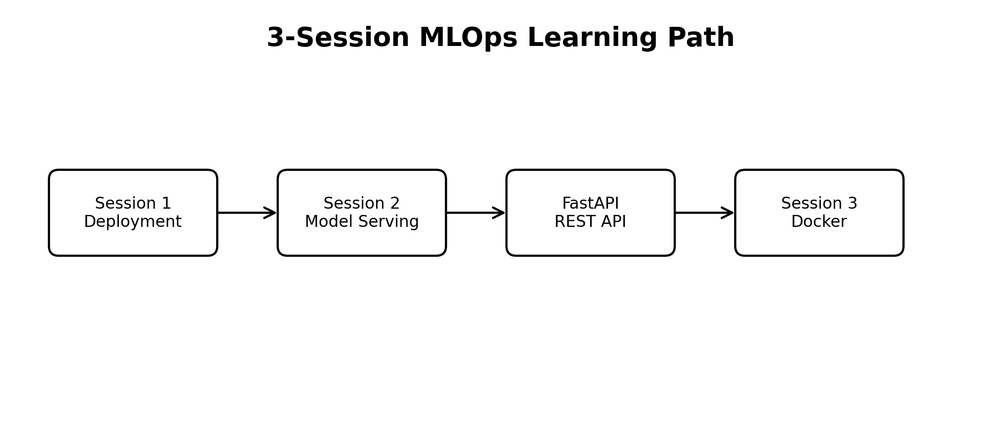
Figure 6. The three hands-on sessions form one continuous MLOps learning path.
Session 1 answers: How should inference be processed — online, batch, or streaming? Session 2 answers: How can we expose the trained model as a reusable service? FastAPI will provide the REST API and Swagger interface. Session 3 answers: How can we package the model-serving application and its dependencies consistently? Docker will provide the containerization layer.

18. Session 1 Summary
TRAINED MODEL
│
├── Online/API → one request → immediate prediction
│
├── Batch → many records → output file/database
│
└── Streaming → continuous records → continuous predictions
Next:
Deployment Strategy → Model Serving (FastAPI) → Containerization (Docker)

